The Rubidium Atom

Rosalyn Chan

York University

PHYS4160

Cody Storry

7th November 2021

**Introduction**

The Rubidium Atom experiment demonstrates some general properties of Rubidium where it describes the general structure of the Rubidium atom with reference to quantum numbers n, L, S, J and F. Here, the application of the Beer-Lambert law is applied to determine the pressure of Rubidium by treating the Rubidium vapour as an ideal gas. Absorption features of four resonances will be observed on the oscilloscope where the Doppler-broadened width will be determined and to examine the absorption spectra of a resonant laser through a Rubidium vapour cell.

**5.2: The Rubidium Atom**

The total electron angular momentum, symbolized J is a combination of the electron orbital angular momentum L, and the electron spin angular momentum S. It is mathematically represented as:

$$\overset{⃑}{J}=\overset{⃑}{L}+\overset{⃑}{S}$$

The magnitude of $\overset{⃑}{J}$ can take values from $\left|L-S\right|$ to $\left|L+S\right|$ in steps of +1.

**5S state of rubidium:**

*L*=0 and *S* = $\frac{1}{2}$

$\overset{⃑}{J}=\left|L-S\right|$ = $\left|0-\frac{1}{2}\right|=\frac{1}{2}$

$\overset{⃑}{J}=\left|L+S\right|$ = $\left|0+\frac{1}{2}\right|=\frac{1}{2}$

The allowed value of $\overset{⃑}{J}$ for the 5S state of rubidium is $\frac{1}{2}$.

**5P state of Rubidium:**

*L*= 1 and *S* = $\frac{1}{2}$

$\overset{⃑}{J}=\left|L-S\right|$ = $\left|1-\frac{1}{2}\right|=\frac{1}{2}$

$\overset{⃑}{J}=\left|L+S\right|$ = $\left|1+\frac{1}{2}\right|=\frac{3}{2}$

The allowed value of $\overset{⃑}{J}$ for the 5P state of rubidium are $\frac{1}{2}$ and $\frac{3}{2}$.

One convert frequency to energy units by using the following expression:

$$E=hf$$

$h:planck constant of$ 6.626× ${10}^{-34}Js$

$${5S}_{\frac{1}{2}}→5P_{\frac{1}{2}}$$

$E=hf=(6.626$ × ${10}^{-34}Js)(380×$ ${10}^{12}s^{-1})=$ 2.518 $×{10}^{-19}$ J

$${5P}_{\frac{1}{2}}→5P_{\frac{3}{2}}$$

$E=hf=(6.626$ × ${10}^{-34}Js)(7×$ ${10}^{12}s^{-1})=$ 4.638 $×{10}^{-19}$ J

Wavelength corresponding to the 5S to 5P energy splitting is

$$λ=\frac{c}{f}$$

$$λ=\frac{c}{f}=\frac{\left(3×{10}^{8}\right)m}{s(380× {10}^{12}s^{-1})}=7.895×{10}^{-7}=789nm$$

Visible light corresponds to the 5S and 5P energy splitting.

In addition to the spin and orbital angular momentum of the electron, the nucleus, symbolized *I*. This angular momentum can couple with the total electron angular momentum to give the total angular momentum *F.*

$$\overset{⃑}{F}=\overset{⃑}{J}+\overset{⃑}{I}$$

The allowed values of total angular momentum are $\left|J-I\right|≤F≤ \left|J+I\right|$ where *F* increases in steps of 1.

${5S}_{\frac{1}{2}}$**:**

*J = $\frac{1}{2}$* and *I = $\frac{5}{2}$*

$$\left|J-I\right|≤F≤ \left|J+I\right|=\left|\frac{1}{2}-\frac{5}{2}\right|≤F≤ \left|\frac{1}{2}+\frac{5}{2}\right|=2≤F≤ 3$$

The allowed values of F are 2 and 3.

${5P}_{\frac{1}{2}}$**:**

*J = $\frac{1}{2}$* and *I = $\frac{5}{2}$*

$$\left|J-I\right|≤F≤ \left|J+I\right|=\left|\frac{1}{2}-\frac{5}{2}\right|≤F≤ \left|\frac{1}{2}+\frac{5}{2}\right|=2≤F≤ 3$$

The allowed values of F are 2 and 3.

${5P}_{\frac{3}{2}}$**:**

*J = $\frac{3}{2}$* and *I = $\frac{5}{2}$*

$$\left|J-I\right|≤F≤ \left|J+I\right|=\left|\frac{3}{2}-\frac{5}{2}\right|≤F≤ \left|\frac{3}{2}+\frac{5}{2}\right|=1≤F≤ 4$$

The allowed values of *F* are 1,2,3 and 4.

**5.2.2: Selection Rules**

The selection rules describe the necessary requirements for the electron to transition from one state to another whereby

$∆L=1$

$∆F=-1,0,1$

The allowable electric-dipole transitions for 87Rb are

, =1 to $F^{'}=0,1,2$ and $F=2$ =1 to $F^{'}=1,2,3$

${5P}_{\frac{1}{2}}→{5S}_{\frac{1}{2}}$, $F=1$ to $F^{'}=1,2$ and $F=2$ =1 to $F^{'}=1,2$

The probable speed for a room temperature distribution of Rubidium is determined from the following expression

$$V=\sqrt{\frac{2K_{B}T}{M}}$$

$K_{B}:$ Boltzmann constant (1.38 $×{10}^{-23}J/K)$

T: Temperature

M: mass of Rubidium atom

Unit conversion is given by:

1u=1.6605402 $×{10}^{-27}$ kg

Mass of 85Rb: 85.4678u = 1.419

Mass of 87Rb: 86.9091835u = 1.443 $×{10}^{-25}kg$

Probable speed of 85Rb:

Probable speed of 87Rb:

Parameter of doppler shift is given by:

$$β=\frac{v}{c}$$

Doppler shift for 85Rb:

=

Doppler shift for 87Rb:

=

**5.6.2: Data Collection**

Doppler- broadened absorption features of Rubidium is observed at scan amplitude setting of 6 and range frequency to 5.

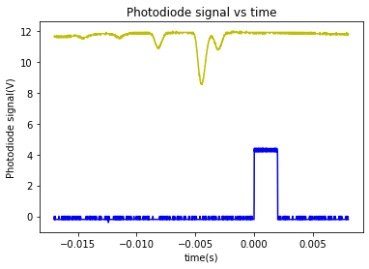

Figure 1: Oscilloscope trace across all four resonances at once.

**5.6.3: Background Subtraction**

The background data is scaled down to overlap the signal data as best as possible to have a better background subtraction as the background beam was at a different intensity level.

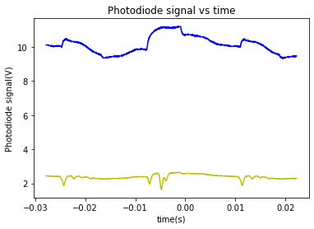

Figure 2: Traces of both photodiode signals on the oscilloscope before background data is scaled.

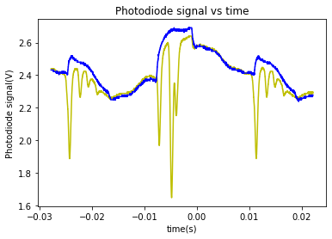

Figure 3: Overlap of traces of both photodiode signals after background data is scaled.

**Part 1:**

Four background absorption features are fitted to a gaussian where the Doppler broadened linewidth of these transitions is determined from the following equation

$$FWHM=2\sqrt{2ln2} σ≈2.355σ$$

$σ$: standard deviation

The scan amplitude used is set to 6 whereby the calibration is 9.090 $×{10}^{9}Hz$.

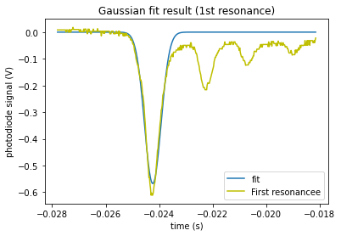

Figure 4: Gaussian fit to the first resonance

Standard deviation of the curve fit, $σ$: 0.000310345 ± 9.50939 $×{10}^{-6}s$

$$FWHM=2.355σ=2.355\left(0.000310345± 9.50939×{10}^{-6}\right)=7.309×{10}^{-4}±2.239×{10}^{-5}s=(7.3±0.2)×{10}^{-4}s$$

Taking the inverse of FWHM to obtain in unit Hz

$$∴linewidth=\left(\frac{1}{7.309×{10}^{-4}s}\right)\left(9.090×{10}^{9}Hz\right)=1.244×{10}^{13}Hz=12.4THz$$

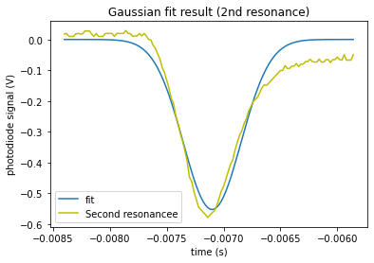

Figure 5: Gaussian fit to the second resonance

Standard deviation of the curve fit, $σ$: (2.53 ± 0.06) $×{10}^{-4}$

$$FWHM=2.355σ=2.355\left(0.000253723± 6.31071×{10}^{-6}\right)=5.975×{10}^{-4}±1.486×{10}^{-5}s=(6.0±0.1)×{10}^{-4}s$$

Taking the inverse of FWHM to obtain in unit Hz:

$$∴linewidth=\left(\frac{1}{5.975×{10}^{-4}s}\right)\left(9.090×{10}^{9}Hz\right)=1.521×{10}^{13}Hz=15.2THz$$

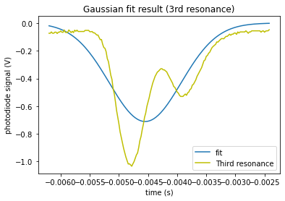

Figure 6: Gaussian fit to the third resonance

Standard deviation of the curve fit, $σ$: (6.17 ± 0.26) $×{10}^{-4}$

$$FWHM=2.355σ=2.355\left(0.000617178 ±2.59278×{10}^{-5} \right)=1.453×{10}^{-3} ±6.106×{10}^{-5} =\left(1.45±0.06\right)×{10}^{-3}s$$

Taking the inverse of FWHM to obtain in unit Hz:

$$∴linewidth=\left(\frac{1}{1.453×{10}^{-3}s}\right)\left(9.090×{10}^{9}Hz\right)=6.27×{10}^{12}Hz=6.27THz$$

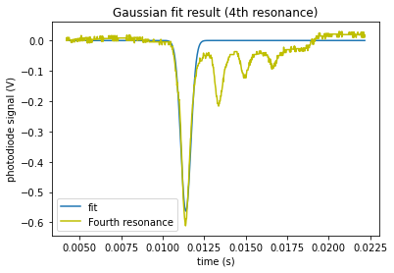

Figure 7: Gaussian fit to the fourth resonance

Standard deviation of the curve fit, $σ$: (3.07 ± 0.07) $×{10}^{-4}$

$$FWHM=2.355σ=2.355\left(0.000307325 ±7.14686×{10}^{-6}\right)=7.238×{10}^{-4}±1.683×{10}^{-5} =(7.2±0.2)×{10}^{-4}s$$

Taking the inverse of FWHM to obtain in unit Hz:

$$∴linewidth=\left(\frac{1}{7.238×{10}^{-4}s}\right)\left(9.090×{10}^{9}Hz\right)=1.256×{10}^{13}Hz=12.6THz$$

**Part 2:**

The number density of Rubidium in the vapour cell is generated by the following Beer-Lambert equation

$$I\left(L\right)=I_{o}e^{-σnL}$$

L: distance the light travels through the absorbing medium

$I_{0}$: initial intensity

$I\left(L\right)$: intensity of light after passing through the medium

$σ$: cross-section of absorption

Considering the largest absorption features, the x-axis of the maximum peak of -0.0048 is taken whereby intensity of light after passing through the medium correspond to 1.648 while the initial intensity of light is 2.672119. The relative intensity that is the ratio between the photodiode signals is found to be $\frac{I(L)}{I_{o}}=\frac{1.648}{2.672119}$. Thus, the number density of Rubidium is

$$⇒ln\left(\frac{I\left(L\right)}{I_{o}}\right)=-σnL$$

$∴n=\frac{-ln\left(\frac{1.648}{2.672110}\right)}{\left(1.4×{10}^{-16}m^{2}\right)\left(75.0×{10}^{-3}\right)m}=4.603×{10}^{16}m^{-3}$

Treating the rubidium vapour as an ideal gas,

$$PV=nK_{B}T$$

$\frac{n}{V}$: the number density of Rubidium atoms

$$⸫ P=\frac{nK_{B}T}{V}=\left(4.603×{10}^{16}m^{-3}\right)\left(1.38×{10}^{-23}\frac{J}{K}\right)\left(300K\right)=1.906×{10}^{-4 }Pa$$

**Part 3:**

We see two peaks for every isotope such that the ${5S}_{\frac{1}{2}}$ and ${5S}_{\frac{3}{2}}$ state have hyperfine splitting where only the ${5S}_{\frac{1}{2}}$ state has a large enough hyperfine splitting than the Doppler broadening. Distance in unit of frequency is determined between two peaks for 85Rb and 87Rb whereby the distance obtained would be the hyperfine splitting of the ${5S}_{\frac{1}{2}}$ state.

The scan amplitude used is set to 6 whereby the calibration is 9.090.

85Rb:

Distance of laser moving through one full cycle: 6.11 $×{10}^{-3}$ s

Distance of a laser going through a single ramp: $3.05×{10}^{-3}$ s

Distance between two peaks: 8.4 $×{10}^{-4}s$

Ratio of distance between two peaks and distance of laser of a single ramp: $\frac{8.4×{10}^{-4}}{ 3.05×{10}^{-3}}=0.275$

$∴hyperfine splitting=(0.275)×$ (9.090 $×{10}^{9}) Hz=2.5×{10}^{9}Hz$.

Accepted value: 3GHz

87Rb:

Distance of laser moving through one full cycle: 6.11 $×{10}^{-3}$ s

Distance of a laser going through a single ramp: $3.05×{10}^{-3}$ s

Distance between two peaks: 2.52 $×{10}^{-3}s$

Ratio of distance between two peaks and distance of laser of a single ramp: $\frac{2.52×{10}^{-3}}{ 3.05×{10}^{-3}}=0.826$

$∴hyperfine splitting=(0.826)×$ (9.090 $×{10}^{9}) Hz=7.5×{10}^{9}Hz$.

Accepted value: 6GHz

$$Percentage error, δ= \left|\frac{v_{A}-v_{e}}{v_{e}}\right|×100\%$$

$$v_{A}=measured value$$

$$v_{e}=expected value$$

$$Percentage error, δ= \left|\frac{v_{A}-v_{e}}{v_{e}}\right|×100\%=\left|\frac{7.5×{10}^{9}-6.0×{10}^{9}}{6.0×{10}^{9}}\right|×100\%=25.0\%$$

**Conclusion:**

The Doppler broadened linewidth for each transition was found to be 12.4THz for the first resonance, 15.2THz for the second, 6.27THz for the third and 12.6THz for the fourth resonance. The number density of Rubidium atoms was found to be 4.603 $×{10}^{16}m^{-3}$ which correspond to a pressure of 1.906 $×{10}^{-4}$ Pa. However, in comparison with the accepted value of the hyperfine splitting of the $5S_{\frac{1}{2}}$ state for 85Rb and 87Rb, the measured value was found to be $2.5×{10}^{9}Hz$ and 7.5 $×{10}^{9}Hz$ respectively. The measured values appeared to be close to the accepted values but with a relatively high percentage error of 16.6% for 85Rb and 25% for 87Rb. This could be due to the fact that the amplitude calibration used here was not done correctly so in the previous lab or the laser beam was being too saturated. Nevertheless, the data and results generated from this experiment is deemed reasonable.

**Appendix A**

Oscilloscope trace of four resonances:

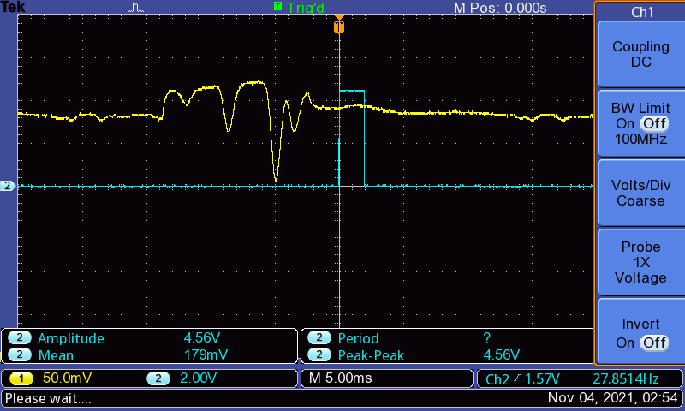

Traces of both photodiode signal on the oscilloscope:

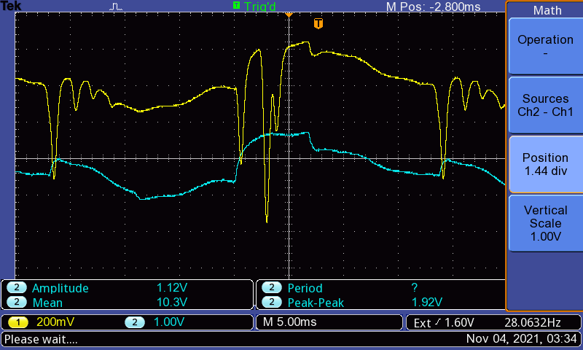

**Appendix B**

Standard deviation for four resonances with its uncertainty in array 2

|  |  |  |
| --- | --- | --- |
| Resonance | Standard deviation | Uncertainty |
| 1 |  |  |
| 2 |  |  |
| 3 |  |  |
| 4 |  |  |

**Appendix C**

Excel file

subtract.xlsx